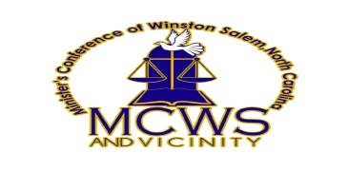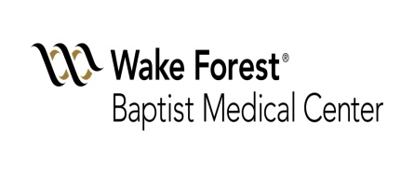
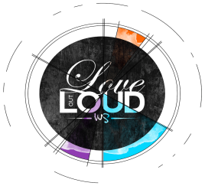
Liability Disclaimer For
The Winston-Salem Hurricane Florence Humanitarian Response Team to Eastern North Carolina (“Response Team”)
The collaborative Partners include: Mayor Allen Joines and the City of Winston Salem, Minister's Conference of Winston Salem & Vicinity, Baptist Hospital & Faith Health Division, Love Out Loud, and Offering for a Hungry Nation. (“The Partners”)
The Partners do not provide liability insurance for the protection of individuals, groups, organizations, businesses, spectators, or others who may participate in the RESPONSE TEAM.
In consideration for your participation in the Response Team, the individual, group, organization, business, spectator, or other, does hereby release and forever discharge THE PARTNERS, and its officers, board, and employees, jointly and severally from any and all actions, causes of actions, claims and demands for, upon or by reason of any damage, loss or injury, which hereafter may be sustained by participating in the RESPONSE TEAM.
This release extends and applies to, and also covers and includes, all unknown, unforeseen, unanticipated and unsuspected injuries, damages, loss and liability and the consequences thereof, as well as those now disclosed and known to exist. The provisions of any state, federal, local or territorial law or state providing substance that releases shall not extend to claims, demands, injuries, or damages which are known or unsuspected to exist at this time, to the person executing such release, are hereby expressly waived.
I hereby agree on behalf of my heirs, executors, administrators, and assigns, to indemnify THE PARTNERS and its officers, board and employees, joint and severally from any and all actions, causes of actions, claims and demands for, upon or by reason of any damage, loss or injury, which hereafter may be sustained by participating in the RESPONSE TEAM.
It is further understood and agreed that said participation in the RESPONSE TEAM is not to be construed as an admission of any liability and acceptance of assumption of responsibility by the PARTNERS, its officers, board, and employees, jointly and severally, for all damages and expenses for which the PARTNERS, its officers, board and employees, become liable as a result of any alleged act of the parade participant.
__________________________________
Name of Individual Responsible (Print)
____________________________________ _________________
Address Phone
_____________________________________ _________________
Signature Date
All participants must complete this Liability Disclaimer to be eligible to participate in the RESPONSE TEAM.
Return completed form and copy of participants ID to: serve@loveoutloudws.com

